**How to Register the SDK?**

Method 1: You can run as the file "Register_SDK.bat" with administrator privilege to register the SDK after uncompress it, it is can use for 32 bit OS and 64 bit OS.

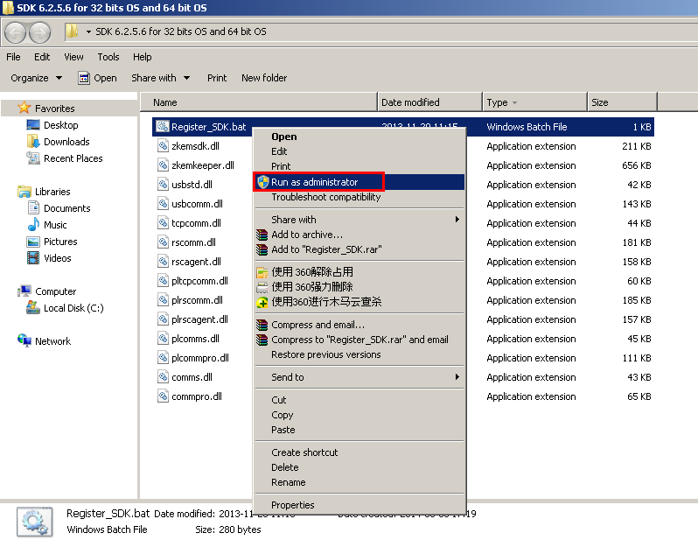

**Method 2:** Firstly, Uncompress the SDK package to a folder, then refer to the steps as below:

**A. 32 bit windows XP/windows Vista/windows 7/ windows 8/ windows server 2008/**

(1).   Copy all sdk *.dll files to %windir%\system32 folder , and then run cmd.exe with administrator privilege ,

(2).  Enter the following command:

regsvr32.exe %windir%\system32\zkemkeeper.dll

**B. 64 bit windows Vista/windows 7/ windows 8/ windows server 2008**

(1).    Copy all sdk *.dll files to %windir%\sysWOW64 folder , and then run cmd.exe with administrator privilege.

(2).    Enter the following command:

%windir%\syswow64\regsvr32.exe %windir%\syswow64\zkemkeeper.dll